**Terraform Installation and Setup**

Follow the below steps to install Terraform on your Windows machine:

1. Go to <https://developer.hashicorp.com/terraform/downloads> and download the latest version for 386:

1. Create a new folder ‘tmp’ in your C:// drive and move the downloaded file into the tmp folder:

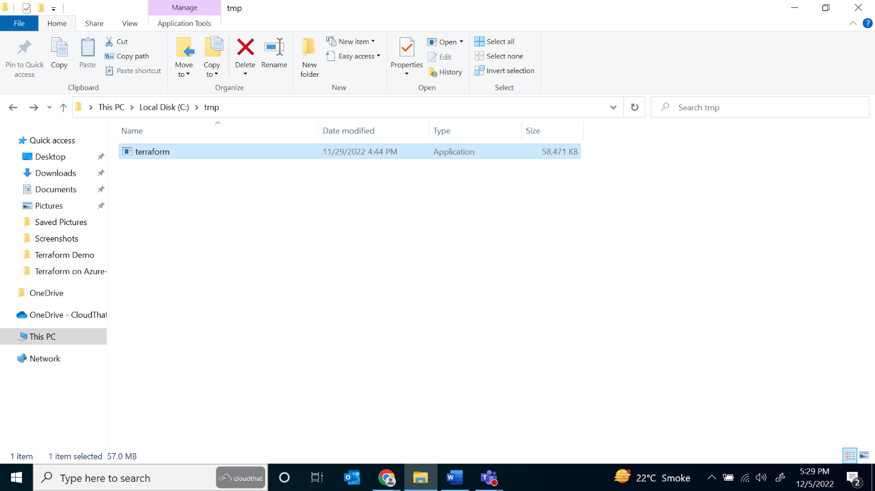

1. Set the path variable in your Windows settings by searching for ‘edit the system environment variables’ or going to settings -> system -> about -> advanced system settings and from there in advanced go to environment variables -> Path (It should already be added in system variables or else add it) -> edit -> C:\tmp and click Ok then again Ok:

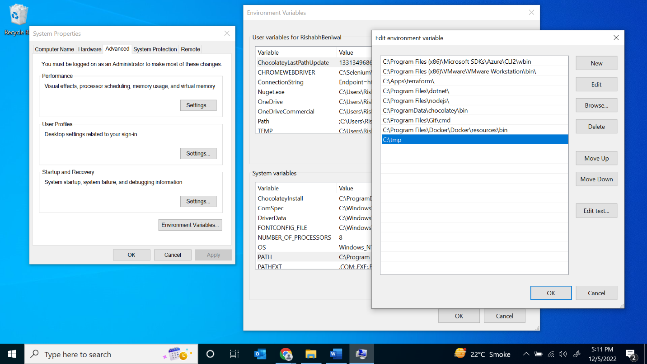

1. Open Visual Studio and go to extensions. Then search for Hashicorp Terraform and install it. Do the same for Azure Terraform:

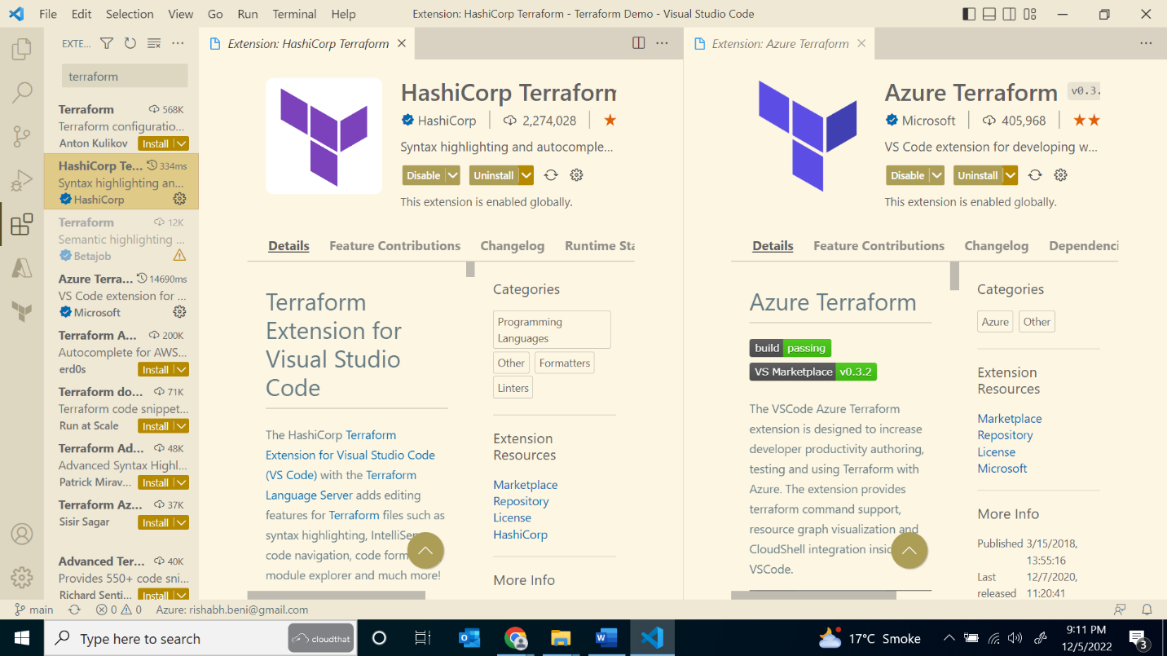

1. Go to File -> New Text File and click on ‘Select a Language’. Once the extensions are installed, you should be able to search for Terraform and select it:

You can save the file in a suitable folder and can start typing code in HCL syntax.